Prelab Activities
1. Matching

For each term in the left column, write the letter for the description from the right column that best matches the term.
term | Description
( ) 1. Inheritance | a) Class from which others are derived.
( ) 2. Abstraction | b) Deriving from more than one base class.
( ) 3. Derived class | c) Class that is created by inheriting from an existing class.
( ) 4. “Has a” relationship | d) The inheritance relationship.
( ) 5. “Is a” relationship | e) Passes arguments to the base-class constructor.
( ) 6. Single inheritance | f) Base class that is not listed explicitly in the derived class's definition.
( )7. Base class | g) “Seeing the forest through the trees.”
（ ）8. Indirect base class | h) The composition relationship.
( ) 9. Base-class initializer | i) Deriving from only one base class.
( ) 10. Multiple inheritance | j) A form of software reusability in which new classes are created from existing classes.

2. Fill in the Blank
Fill in the blanks in each of the following statements:
11. Inheritance promotes software .
12. The programmer can designate that a new class is to I the data members and member functions of a previously defined base class.
13. A base class’s members may be accessed by members and friends of the base class and by members and friends of the derived class.
14. With inheritance, a class is derived from only one base class.
15. A derived class cannot access the members of its base class; allowing such access would violate the enscapulation of the base class.
16. A derived class’s constructor always calls the constructor of its first.
17. Destructors are called in order of constructor calls.
18. The three forms of inheritance are , and .
19. With private inheritance, public and protected members of the base class become
members of the derived class.
20. A(n) base class is not explicitly listed in the derived-class definition; rather, it is inherited from several levels up the class hierarchy tree.
21. A pointer to a derived-class object can be cast implicitly to a(n) pointer.
3. Programming Output

22. What is output by the following program?
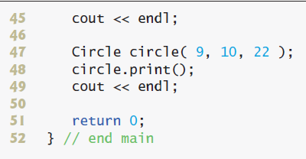
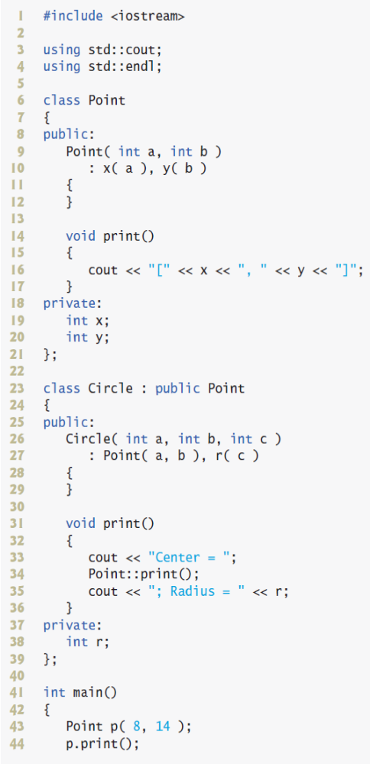

Your answer:

23. What is output by the following program?
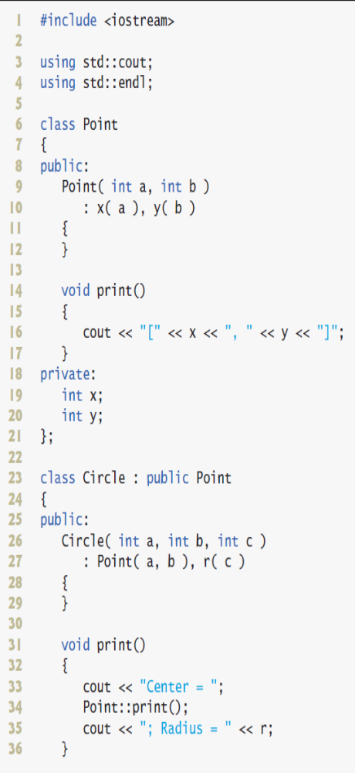
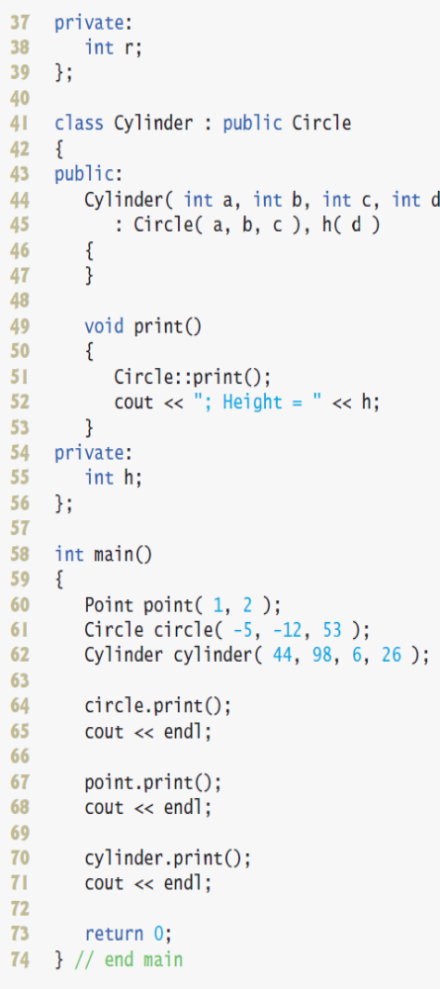

Your answer:

4. Correct the Code

31. Class X inherits from class Y.
32. The following code should construct a Derived object.

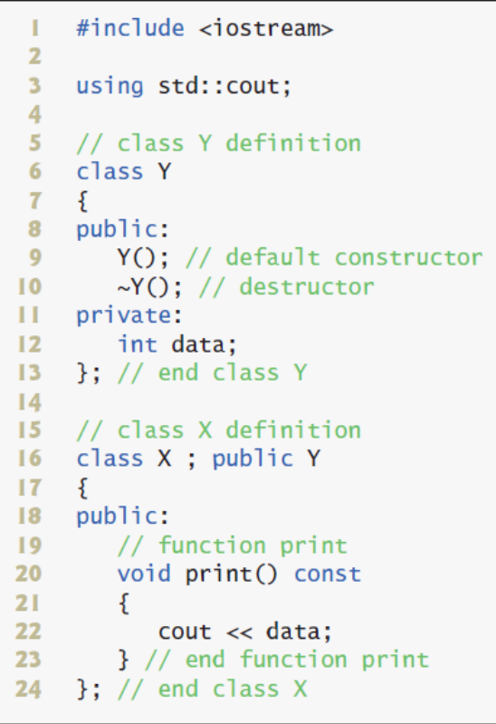

Your answer:

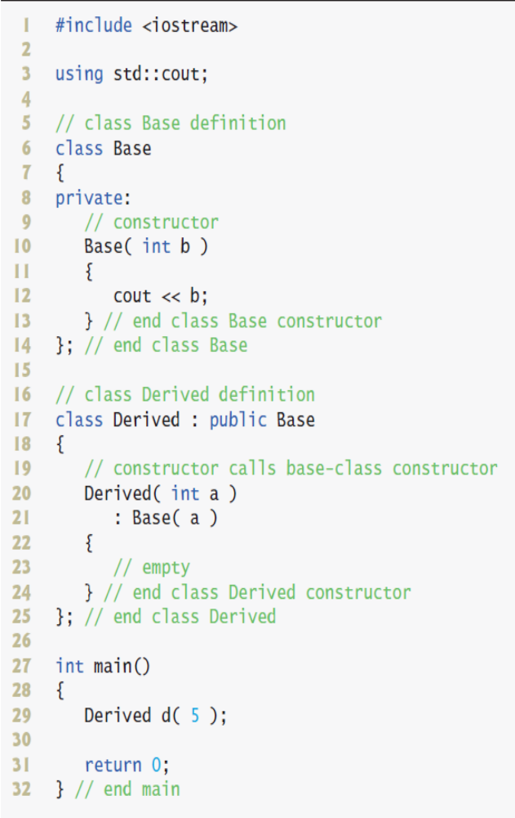

Your answer:

33. The following code creates an object of type B. Class B inherits from class A.

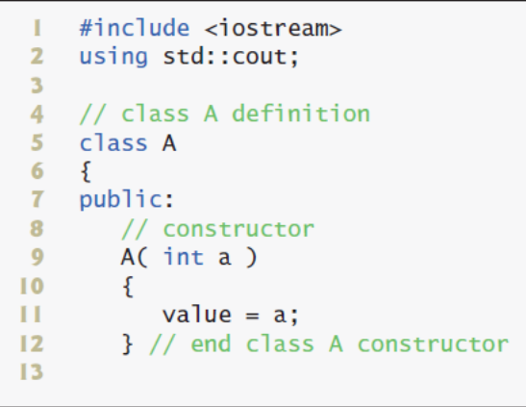
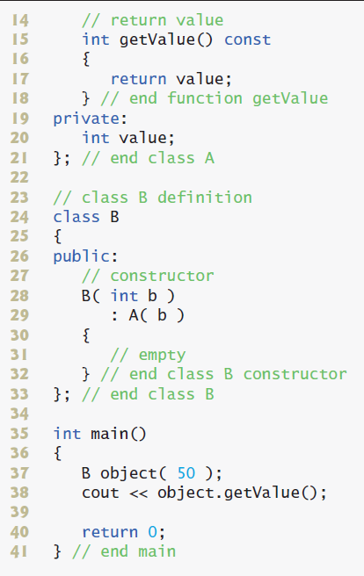
Your answer:

34. The following code creates an object of type Y. Class Y inherits from class X.

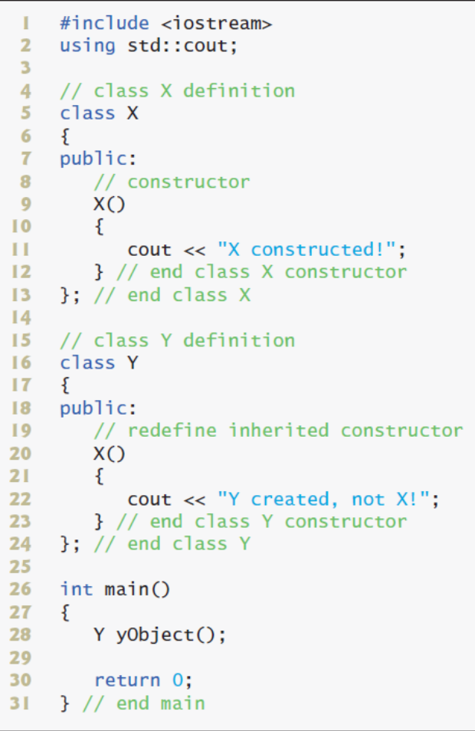

Your answer:

Name: Date:

